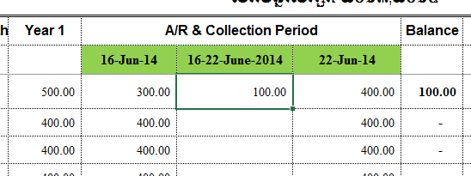

**Total of payment**

**2, 3… payment Fee**

**Until date line of payment at 22-Jun-2014.**

**So student can pay many time before dateline.**

**First payment Fee**

**In 16-Jun-2014**

**School Fee**